Art: Its History and Meaning

Spring 2022
Instructor: Prof. Khushmi Mehta
kmehta@gradcenter.cuny.edu
Tuesdays and Thursdays, 9:30 to 10:45, 3139 Boylan Hall
Class website: https://mehtaspring22.commons.gc.cuny.edu

Course Objectives
In this class, students will:
- Acquire familiarity with artworks from a range of geographical regions, cultures, and mediums and gain an understanding of the multiplicity of chronologies within art history.
- Critically engage in discussions about the roles of art institutions, the role of art in social movements, and an interpretation of artworks as artifacts of social, political and economic discourse.
- Develop skills of visual analysis and learn methodologies including citation practices and research techniques used to build art historical arguments.

Pathways Learning Outcomes:
1. Gather, interpret, and assess information from a variety of sources and points of view.
2. Evaluate evidence and arguments critically or analytically.
3. Produce well-reasoned written or oral arguments using evidence to support conclusions.
4. Identify and apply the fundamental concepts and methods of a discipline or interdisciplinary field exploring creative expression, including, but not limited to, arts, communications, creative writing, media arts, music, and theater.
5. Analyze how arts from diverse cultures of the past serve as a foundation for those of the present and describe the significance of works of art in the societies that created them.
6. Articulate how meaning is created in the arts or communications and how experience is interpreted and conveyed.

Communication and Office Hours
- Email and the CUNY Commons group are the primary means of communication for this course. I do my best to reply to emails within 24 hours.
- Students are expected to check email frequently and ensure that the email you use most frequently is linked to the CUNY Commons group.
- I am available for virtual office hours by appointment. I welcome conversations at any point of the semester regarding learning styles, final paper topics, progress check-ins etc.

Class policies

Attendance + COVID-19
- You are expected to attend classes every Tuesday and Thursday, and actively participate in the discussions. If you are unable to attend class due to illness, religious holiday, or another legitimate conflict, please email me in order to be excused.
- Taking into consideration the situation of the pandemic, I will make accommodations to the attendance policy as needed. If you are feeling sick or have been exposed to COVID-19, please get tested, then stay home and email me to let me know. If you are able to attend virtually, I will make arrangements for you to attend via Zoom.
- CUNY is offering free PCR testing at CUNY testing sites to all CUNY students. If you have tested positive, email me immediately and follow the instructions on this infographic:

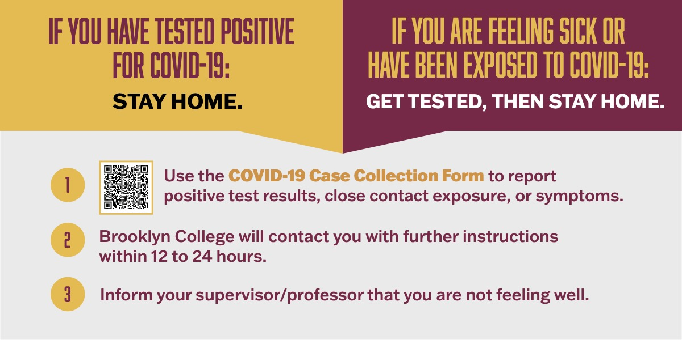

Deadlines
Late submissions will be graded down by one letter grade. You are responsible for all assignment due dates. Extensions must be requested at least 24 hours in advance, other than those for unforeseen circumstances such as illness or family emergencies. Extensions will be granted at the discretion of the instructor.

Required readings
There are no books to purchase for this course. PDFs of the readings are posted on the class website. You are expected to come to the Zoom sessions having completed the readings and prepared to have a discussion on them.

Student accommodations
The Center for Student Disability Services (CSDS) is committed to ensuring students with disabilities enjoy an equal opportunity to participate at Brooklyn College. In order to receive disability-related academic accommodations, students must first be registered with CSDS. Students who have a documented disability or suspect they may have a disability are invited to schedule an interview by calling (718) 951-5538 or emailing Josephine.Patterson@brooklyn.cuny.edu. If you have already registered with CSDS, email Josephine.Patterson@brooklyn.cuny.edu or testingcsds@brooklyn.cuny.edu to ensure accommodation emails are sent to your professor.

Plagiarism and Academic Integrity
The faculty and administration of Brooklyn College support an environment free from cheating and plagiarism. Each student is responsible for being aware of what constitutes cheating and plagiarism and for avoiding both. The complete text of the CUNY Academic Integrity Policy and the Brooklyn College procedure for policy implementation can be found at www.brooklyn.cuny.edu/bc/policies. If a faculty member suspects a violation of academic integrity and, upon investigation, confirms that violation, or if the student admits the violation, the faculty member MUST report the violation. Students should be aware that faculty may use plagiarism detection software.

Assignments and grading

Blog posts: 10%
- Each Wednesday, you will be writing a short post (about 1 paragraph) on the CUNY Commons forum on the topic for that week. Your post should be a reflection on ideas that stood for you from the previous class and questions you would like to discuss further for the next one.
- This blog is intended to be an informal space of discussion. You are not being graded on the complexity or language of these posts, but rather for participation and understanding of the material. You can be as creative as you like with your posts! Feel free to attach images, links or other media to your posts.

Class participation: 10%
- You will be assessed based on your participation during the class. I encourage students to actively ask questions, develop their ideas beyond what is presented through the course material and push the limits of the topics each week.
- One of the objectives of this course is to develop skills of writing and analysis. For this, we will work on writing assignments and worksheets in class related to the weekly topics which will also contribute to your class participation grade.

Close reading essay: 20%
- 3-4 pages (not including images), double spaced, 12-point Times New Roman font
- For this assignment you will create an illustrated essay that closely examines one work of art from an NYC museum collection, linking the visual analysis to the artwork’s socio-historical context.

Midterm Exam: 20%
- The midterm exam will be conducted in class on 24 March. This exam will test your understanding of key concepts and ideas introduced in class, and skills of visual analysis.

Final research paper: 40%
- 5-6 pages (not including images and citations), double spaced, 12-point Times New Roman font
- The final paper is designed as a staggered assignment, which means that the assignment will be broken down into steps leading up to the final submission. Through this, you will develop skills of art historical research, learn how to formulate a scholarly argument, and get the opportunity to explore topics beyond what was covered in the course.

Assignment revisions
Other than the final paper, I will allow for revisions to submitted essays within one week of receiving comments and grades. The grade may be revised if there is a significant improvement from the initial submission incorporating the feedback received.

Extra credit
There will be a few opportunities for extra credit throughout the semester in the form of online events relevant to the course material. The details of the events will be posted on the CUNY Commons website. If you attend any of the listed events, please submit a ½-1 page reflection on the event to be graded for extra credit.

Class schedule
Note: I may make slight changes to the material or dates over the course of the semester. These changes will be made in accordance with class needs and you will be given as much notice as possible. In case of changes, I will make an announcement and upload the updated syllabus to the Commons website.

Unit 1: Introduction
T 1 Feb: Introductions, Syllabus review

Unit 2: Culture formations

Th 3 Feb: Prehistoric art
In class exercise: How to describe an artwork

T 8 Feb: No class (classes follow Friday schedule)

Th 10 Feb: Egyptian art
In class exercise: Visual Analysis from home

Unit 3: Art, Myth and Power

T 15 Feb: Ancient Near Eastern Art
Th 17 Feb: Greek and Roman art

Unit 4: Sacred Spaces

T 22 Feb: Byzantine Art and Architecture
Th 24 Feb: Art of the Americas

Unit 5: The Soul of Objects

T 1 Mar: Pre-modern African art
In class exercise: The Restitution Debate

Th 3 Mar: Hindu art and architecture
Sunday 6 Mar: Close reading essay due

Unit 6: Art, Faith and Philosophy

T 8 Mar: Islamic art
Th 10 Mar: Art of Imperial China

Unit 7: European Art through the Ages

T 15 Mar: The Middles Ages to the Renaissance
Th 17 Mar: Baroque to Impressionism

Unit 8: Picturing the Other

T 22 Mar: Colonialism and Orientalism
In class exercise: How to analyze an artwork

Th 24 Mar: Midterm Exam

Unit 9: Modernism and Tales of Progress

T 29 Mar: Cubism and Futurism
T 31 Mar: Dadaism and Surrealism

Unit 10: Art and Revolution

T 5 Apr: Harlem Renaissance
Th 7 Apr: Chinese Cultural Revolution

Friday 8 May: Research topic selection

Unit 11: Conducting Research

T 12 Apr: Research workshop I
Seminar: how to find sources, how to select artworks
Th 14 Apr: Research workshop II
Seminar: developing an argument, forming a thesis, citing your sources

* Fri 15 Apr to 22 April: Spring break (no classes)

Unit 12: National Modernisms

T 26 Apr: Mexican Muralism
Th 28 Apr: Post-Independence African and South Asian Art

Unit 13: Embodied Art

T 3 May: Abstract Expressionism and Japanese Gutai
Th 5 May: Performance art and Institutional Critique

Friday 6 May: Drafts due

Unit 14: Image politics

T 10 May: Pop art
Th 12 May: Feminist art of the 1980s

Unit 16: Reading/Finals week

T 17 May: Open office hours
Th 19 May: Open office hours

Friday 20 May: Final papers due

Course related notices

Note on research during the pandemic
If there’s one thing the past year has shown us, it’s that circumstances will likely change over the course of the semester and we need to be flexible. Considering that physical access to libraries and other research facilities may still be difficult, over the course of the semester, you will be introduced to online resources to engage with art history from home and conduct research for the final project. If you have concerns or any issues that arise during the semester due to the pandemic that are affecting your ability to participate, complete assignments, etc. please reach out to me.

Brooklyn College has made a number of resources available for students during the ongoing pandemic. These can be found here: https://www.brooklyn.cuny.edu/web/about/offices/studentaffairs/health-wellness/coronavirus/student-resources.php

Note on writing and language
If you need help with your writing or learning, I would encourage you to work with a writing tutor. Especially if English is not your first, (or second, or third!) language, please know that I will not penalize grammatical or spelling errors in exams or papers. It is important that your ideas are clearly conveyed and your writing reflects a good understanding of the content. If you are worried about this, please let me know and we can discuss strategies for you to get the best out of assignments and convey your thoughts most effectively.
However, writing academic research papers is one of the learning objectives of this course and is a skill we will be working on throughout the semester. The assignments and workshops are therefore designed to provide you with tools to develop this skill. If you are dealing with any kind of hindrance to your writing, please try to communicate with me about it so that I can do my best to support you.

Campus resources
Brooklyn College offers a number of services to support all students. free counselling, a center for disability services where students can get evaluated if they are not already diagnosed, a food pantry, immigration services as well as services for undocumented and DACA recipients, veteran and active military services, groups for Women, Black and Latino Males, and LGBTQ students, in addition to emergency financial assistance and a health clinic. All can be found on this page: https://www.brooklyn.cuny.edu/web/about/offices/studentaffairs/student-support-services.php. You also have access to a Personal Counselling program, details of which can be found here: https://www.brooklyn.cuny.edu/web/about/offices/studentaffairs/student-support-services/isso/counseling.php

Gender and identity
It is CUNY policy, along with my own, to use proper names rather than gender binary Ms/Miss/Mrs/Mr. If you have a preferred name or form of address, please let me know and I will change the register. My own pronouns are She/Her.

Sensitive content notice
Art History often presents us with images and histories that can be triggering, painful, or covered by religious taboo. If for whatever reason you have objections to looking at particular material (images of the nude body, for example) please understand that such images may come up for discussion and that if they are important to the syllabus, they cannot be censored from it. However, to the best of my ability, I will try to anticipate this, provide trigger warnings and create the space for us to discuss difficult material sensitively and openly as a group.

I also welcome feedback from students who identify with the material we discuss in this course and wish to help all of us understand it more richly, personally, and responsibly, (during and even after class). I will do my best to maintain an atmosphere of care and careful listening in this course and will appreciate all students doing the same.

Code of conduct
It is extremely important that the classroom be a safe and respectful environment for all students. To that end, there are a few expectations for behaviour in all learning spaces, including class discussions and the blog posts. When responding to a classmate, please do so respectfully, even when disagreeing. When disagreeing offer evidence or ask questions in a collegial way that encourages further discussion, rather than invalidating a classmate’s ideas. Should there ever be an issue, please feel free to contact me.

